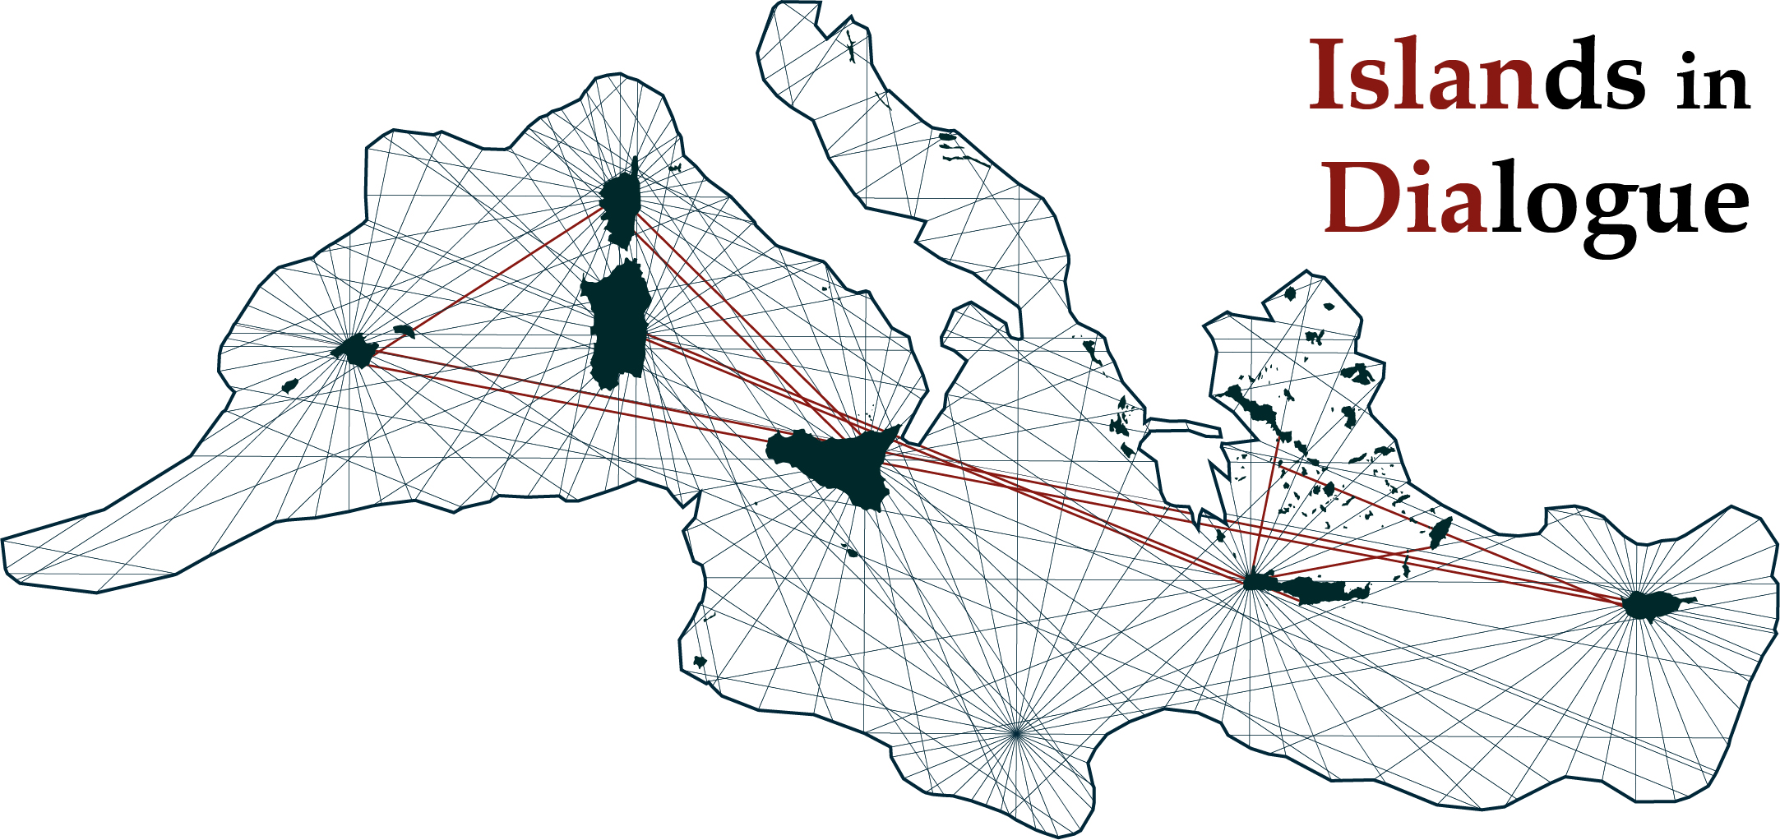

Islands in Dialogue (ISLANDIA)

International Postgraduate Conference in the Prehistory and Protohistory
of Mediterranean Islands

Università di Torino, 14th–16th of November 2018

APPLICATION FORM

Personal data

First name*: ……………………………………Surname*:…………………………………………

Institution (otherwise, please state ‘Independent Researcher’)*: ………………………………………….…

Address:………………………………………………………………………………………………

..........................................................................................................................................................…

..............................................................................................................................................................

Postcode: ………………………………

Phone:…………………………………… Email*: ..........……………………….………….

Paper information
Title*: …………………………………………………………………………………………………………
…………………………………………………………………………………………………………………
…………………………………………………………………………………………………………………

Abstract (max. 300 words)*: ………………………………………………………………………………………………………
…………………………………………………………………………………………………………………
…………………………………………………………………………………………………………………
…………………………………………………………………………………………………………………
…………………………………………………………………………………………………………………
…………………………………………………………………………………………………………………
…………………………………………………………………………………………………………………
…………………………………………………………………………………………………………………
…………………………………………………………………………………………………………………
…………………………………………………………………………………………………………………
…………………………………………………………………………………………………………………
…………………………………………………………………………………………………………………
…………………………………………………………………………………………………………………
*required fields

The conference fee is 35 euro per person. Participants will need to meet their own accommodation and travel costs.

Please send this form to: islandia@unito.it

Application deadline: 20th May 2018

