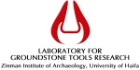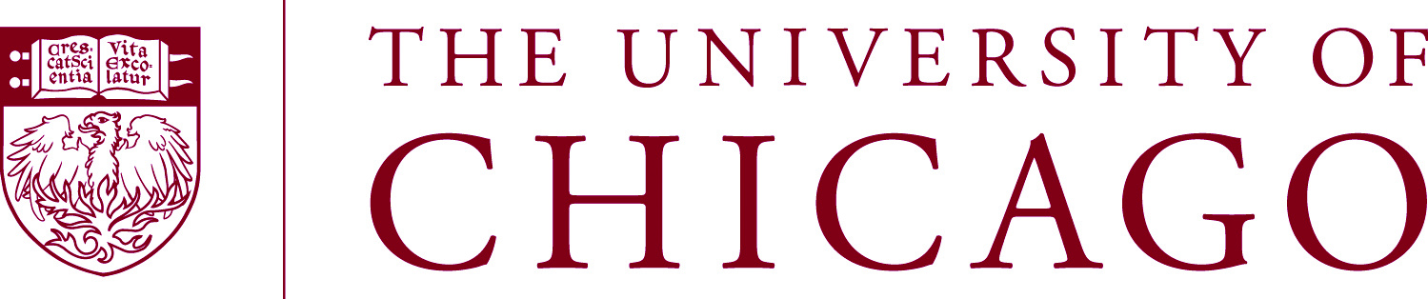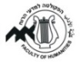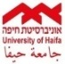

<<< First Circular>>>

Ground Stone Artifacts and Society

An international workshop on ground stone artifacts:
Quarrying, production, function and exchange

<<July 2015 – University of Haifa>>

Dear friends and colleagues
It is our pleasure to invite you to participate in an international workshop on ground stone artifacts. The workshop will be held at the University of Haifa, Israel (tentative dates: July 6–9, 2015). This first circular is aimed at providing basic ideas about the workshop themes, the general outline and to begin a dialogue with potential participants. If you have an interest in broadening and developing the approaches to ground stone artifact analysis and would like to participate, we encourage you to contact us as soon as possible so that we can begin to evaluate the number of participants and sessions. Please send all communications (emails, suggestions and comments) to Danny Rosenberg (drosenberg@research.haifa.ac.il). Don’t hesitate to forward this email to any of your colleagues who might have an interest in taking part in the workshop.

Organizing committee
- Danny Rosenberg, Laboratory for Ground Stone Tools Research, Zinman Institute of Archaeology, University of Haifa (drosenberg@research.haifa.ac.il)
- Yorke M. Rowan, Oriental Institute, University of Chicago (ymrowan@uchicago.edu)
- Tatjana M. Gluhak, Institut für Geowissenschaften, Johannes Gutenberg-Universität Mainz (gluhak@uni-mainz.de).
Themes
Studies of ground stone increasingly play an integral role in any truly holistic archaeological research program. Ground stone artifacts served in widely divergent physical and social contexts through millennia, reflecting a wide variety of functions, documented through a century of archaeological and ethnographic research. Although commonly associated with prosaic daily necessities such as food production, this important functional role is often treated as their sole purpose. However, ground stone artifacts are also used for a wealth of other functions such as processing other materials, tool manufacture, and storage; they also carry symbolic meanings, serve as markers of identity, or are imbued with religious or ideological significance.
Taken together with other categories of material culture as part of the functional and cultural fabric of a society, contemporary ground stone studies are treated in various ways by different scholars who employ a range of analytical methods and approaches, including the application of scientific techniques. Inspired by these diverse analytical approaches and interpretive challenges, one of the principle aims of this workshop is to promote a dialogue and create an optimal arena for scholars who are interested in ground stone artifact studies and the various issues related to this growing area of research. We would like to initiate discussions on various ground stone related topics in order to debate new methodologies and interpretations, discuss analytical currents, and exchange ideas concerning challenges of data storage and presentation.
General topics and sessions
We envision several ground stone-related thematically driven topics that could be used as starting points for different discussions and could be used as titles for sessions. These include, for example, the social context of ground stone artifacts in different geographic locations, periods and cultures; quarries, quarrying technologies and quarrying tools; production techniques; archaeometric and provenance studies; micro/macro-wear and residue analyses and other functional studies; trade and exchange systems and mechanisms; studies of bedrock features; ethnography of ground stone use; ground stone in prehistory and in later antiquity. Other topics and themes are also welcome. The number of sessions and their principle themes will be decided when the deadline for sending abstracts is due and all abstracts are considered.

Technical Information
Duration and tentative dates: 4 days, 6-9 July 2015.
Location: The workshop will take place in the University of Haifa, Mount Carmel, Israel.
Oral contributions: Oral contributions will be 15 minutes long followed by a 5 minutes discussion.
Poster presentation: Poster presentations are also welcome.
Abstracts: An abstract of approx. 300 words (including author’s details and institutional affiliation).
Language: English is the official language for the Conference.
Deadline for submitting abstracts: TBA.
Deadline for registration: TBA.
Workshop fees: TBA.
Accommodations: We will seek fare rate accommodation in Haifa.
Transportation to Haifa: Convenient trains and buses run frequently from Ben-Gurion Airport.
Field trip: Optional, we are planning a field trip on the 3rd day of the workshop.

Best regards,
Danny, Yorke and Tatjana

